Thermometer Shift Register Unit
hyp_adc_cdr_dac_sr_unit
Block Description & Usage Guide

Date | 2026-07-20
Version | 1.0
Status | Verified against Spectre netlist

1. Overview
The hyp_adc_cdr_dac_sr_unit is a 4-mux bidirectional thermometer shift register that converts gray-coded control signals into a 4-bit thermometer output (codes 0 through 4). It is the fundamental building block of the CDR DAC's digital control path.
Each gray code step (single-bit toggle of vsel<1:0>) increments or decrements the thermometer code by exactly 1. The block uses cross-coupled mux pairs for state retention — no clock or flip-flops required.

1.1 Port List
Port | Direction | Width | Description
in_pre | Input | 1 | Right boundary input (tie to VDD = 1 for UP path)
in_post | Input | 1 | Left boundary input (tie to VSS = 0 for DOWN path)
vsel<1:0> | Input | 2 | Gray-coded shift control (see Section 3)
sel_rst | Input | 1 | Async reset enable (active high)
vin_rst_b | Input | 1 | Single-bit reset data (active-low) shared by all 4 muxes. vout = !vin_rst_b: assert low (0) → ON/1111, deassert high (1) → OFF/0000.
vout<3:0> | Output | 4 | Thermometer code output
vcca0p9 | Supply | 1 | 0.9V supply
vssx | Supply | 1 | Ground

2. Architecture

2.1 Mux Cell: hyp_adc_cdr_dac_mux_wr2
Each mux_wr2 contains two cascaded inverting mux stages:
data inputs ──→ [I_mux] ──voutb──→ [I_mux_rst] ──→ vout
↑ ↑
sel sel_rst, vin_rst_b
I_mux: voutb = !(sel ? in1 : in0) ← data mux (inverting)
I_mux_rst: vout = !(sel_rst ? vin_rst_b : voutb) ← reset mux (inverting)
Normal mode (sel_rst=0): vout = sel ? in1 : in0 (double inversion cancels)
Reset mode (sel_rst=1): vout = !vin_rst_b (INVERTED reset!)
NOTE: All 4 muxes in the SR unit share the SAME vin_rst_b signal.
Therefore reset always produces all-0 or all-1 outputs.

2.2 Top-Level Connectivity
The 4 muxes are wired in an asymmetric pattern that creates sliding cross-coupled pairs. The connections from the Spectre netlist are:
Instance | in0 (sel=0) | in1 (sel=1) | sel | Output
I_mux0 | in_pre | vout1 | vsel<1> | vout0
I_mux1 | vout0 | vout2 | vsel<0> | vout1
I_mux2 | vout3 | vout1 | vsel<1> | vout2
I_mux3 | in_post | vout2 | vsel<0> | vout3

Key wiring observations:
- • Even muxes (0, 2) share sel = vsel<1>; odd muxes (1, 3) share sel = vsel<0>
- • in0 port of each mux — connections chain: in_pre → vout0 → vout3 → in_post (note mux2.in0 = vout3, not vout1 — this is the critical asymmetry)
- • in1 port of each mux — connections cross-link: vout1 → vout2 → vout1 → vout2 (mux0 and mux2 both read vout1; mux1 and mux3 both read vout2)

2.3 Block Diagram
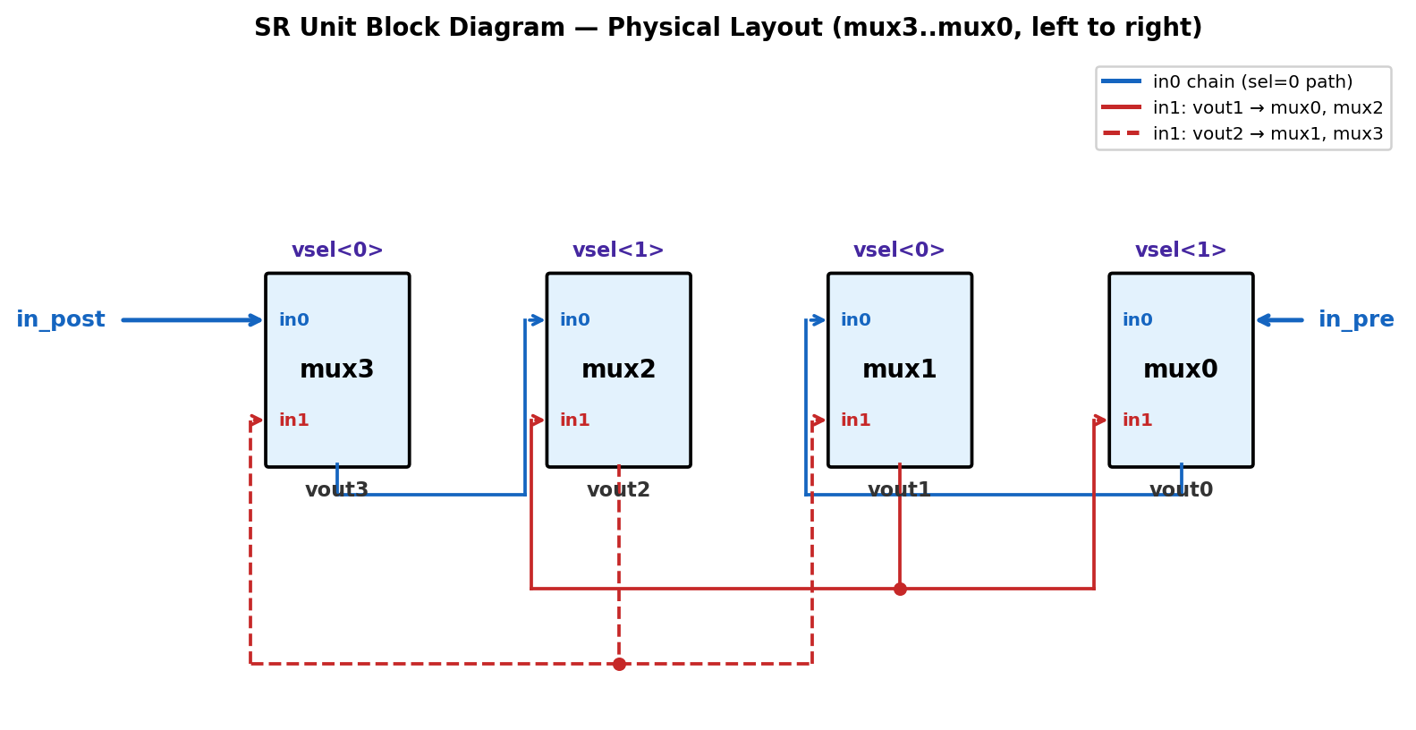
in1 cross-links: mux0.in1 = vout1, mux1.in1 = vout2
mux2.in1 = vout1, mux3.in1 = vout2
in0 chain: mux0.in0 = in_pre, mux1.in0 = vout0
mux2.in0 = vout3, mux3.in0 = in_post

3. Gray Code Operation

3.0 Bit Ordering Convention
Throughout this document, the 4-bit thermometer output is written as [vout0, vout1, vout2, vout3]. In the physical layout, mux0 (vout0) is on the RIGHT and mux3 (vout3) is on the LEFT. The 'ON' region fills from the in_pre side (right/vout0) toward the in_post side (left/vout3):
Code 0: 0000 (all OFF)
Code 1: 1000 (vout0 ON)
Code 2: 1100 (vout0, vout1 ON)
Code 3: 1110 (vout0, vout1, vout2 ON)
Code 4: 1111 (all ON)
Bit position: [vout0] [vout1] [vout2] [vout3]
Physical: (right) (left)
Boundary: in_pre ──── fills this way ───→ in_post
(=1) (=0)

3.1 What is a Cross-Coupled Pair?
A 'pair' is formed when two muxes point at each other's output, creating a feedback loop that acts as a 1-bit latch. No clock is needed — the pair holds its value indefinitely through positive feedback, just like a cross-coupled inverter (SRAM cell).
How it works: When sel=1, a mux selects its in1 port. The in1 ports are cross-linked between pairs of muxes (vout1↔vout2 via mux0/mux2, and vout2↔vout1 via mux1/mux3). When BOTH muxes in a pair have sel=1, each reads the other's output — forming a stable feedback loop.
Example — vsel=10 (sel<1>=1, sel<0>=0), pair at (mux0 ↔ mux1):
mux0: sel<1>=1 → selects in1 = vout1 → so vout0 = vout1
mux1: sel<0>=0 → selects in0 = vout0 → so vout1 = vout0
↕
vout0 = vout1 = vout0 = ... (LATCH!)
If previously vout0=1, vout1=1 → pair holds '1'
If previously vout0=0, vout1=0 → pair holds '0'
The pair is BISTABLE: it can hold either value. The value it actually
holds depends on what was written into it by the previous gray code step.
Why does this matter? The pair value determines the thermometer code. The non-pair muxes are either forced by boundaries (in_pre=1, in_post=0) or they 'follow' the pair value. So changing the pair's value (by moving it to capture a boundary) shifts the thermometer code by ±1.

3.2 Pair Formation per vsel State
At each vsel value, a different pair forms (or none at all). The table below shows which pair is active, what gets forced by boundaries, and which codes are holdable:
vsel<1:0> | Cross-coupled pair | Forced pins | Followers | Holdable codes
00 | None (no pair) | vout0=in_pre=1, vout3=in_post=0 | vout1=vout0, vout2=vout3 | Code 2 only (forced)
01 | mux2 ↔ mux3 | vout0 = in_pre = 1 | vout1 = pair value | Code 1 (pair=0) or Code 4 (pair=1)
10 | mux0 ↔ mux1 | vout3 = in_post = 0 | vout2 = pair value | Code 0 (pair=0) or Code 3 (pair=1)
11 | mux1 ↔ mux2 | — | vout0 = pair, vout3 = pair | Code 0 (pair=0) or Code 4 (pair=1)

3.3 Pair Diagrams per vsel State
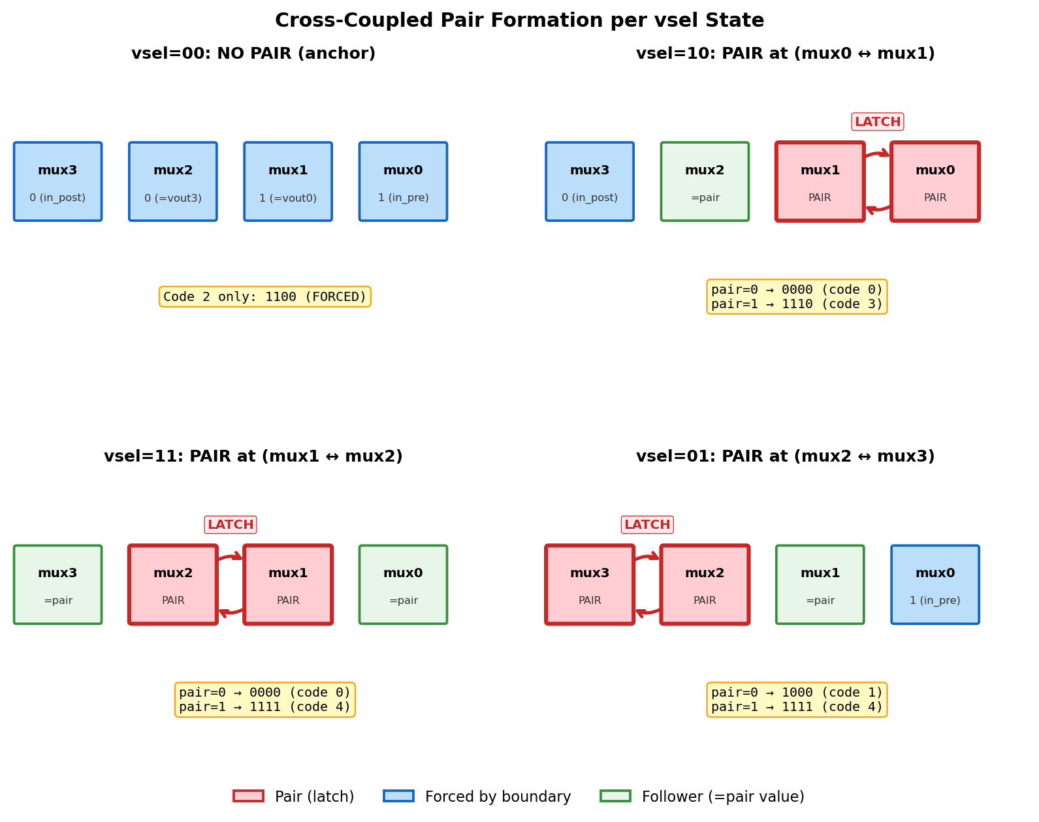

3.4 How Gray Code Steps Produce ±1
Each gray code transition toggles exactly 1 bit of vsel, which moves the cross-coupled pair by one position. The pair captures the boundary value from the side it moves toward, extending or shrinking the thermometer code by 1.
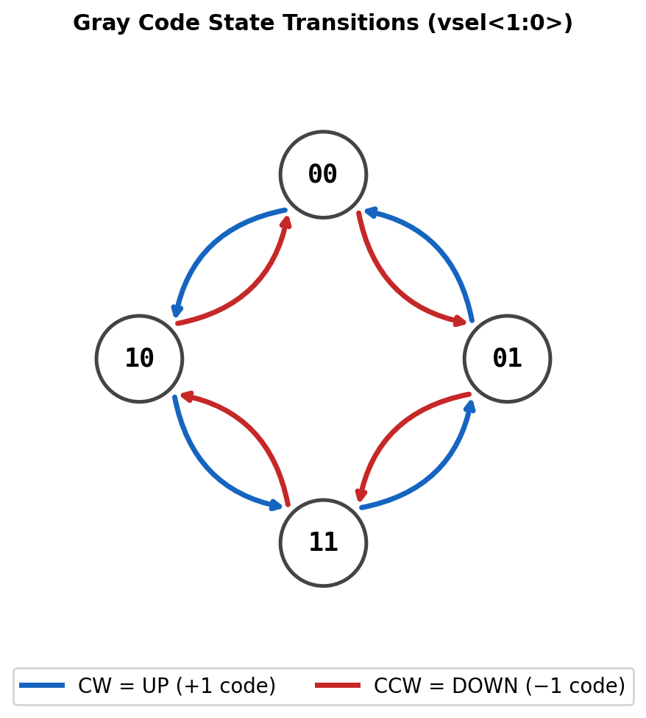
- Clockwise (CW) gray code = UP (+1):
00 ──→ 10 ──→ 11 ──→ 01 ──→ 00
(c2) (c3) (c4) (sat) (back to anchor)
From code 0 at vsel=11:
11(0) → 01(1) → 00(2) → 10(3) → 11(4) → 01(4,sat)
- Counter-clockwise (CCW) gray code = DOWN (−1):
00 ──→ 01 ──→ 11 ──→ 10 ──→ 00
(c2) (c1) (c0) (sat) (back to anchor)
From code 4 at vsel=11:
11(4) → 10(3) → 00(2) → 01(1) → 11(0) → 10(0,sat)

3.5 Code-vsel Mapping
Each thermometer code is associated with a specific vsel state during normal operation:
Code | Thermometer [vout0..3] | Active vsel | Pair | Pair value
0 | 0000 | 10 or 11 | (0↔1) or (1↔2) | 0
1 | 1000 | 01 | (2↔3) | 0
2 | 1100 | 00 | none (forced) | —
3 | 1110 | 10 | (0↔1) | 1
4 | 1111 | 01 or 11 | (2↔3) or (1↔2) | 1

- Note: Thermometer bits listed as [vout0, vout1, vout2, vout3]. Physically: vout0 (mux0) is on the RIGHT, vout3 (mux3) is on the LEFT. The '1' bits fill from the in_pre/mux0 side. Code 2 = 1100 means vout0=1, vout1=1, vout2=0, vout3=0.

3.6 Shift Example: Code 2 → Code 3 (CW step 00→10)
BEFORE (vsel=00): AFTER (vsel=10):
No pair, forced Pair forms at (0↔1)
mux0=1 (from in_pre) mux0 ←→ mux1 PAIR
mux1=1 (follows mux0) Both were 1 → latch 1
mux2=0 (follows mux3) mux2 follows pair → 1 (was 0!)
mux3=0 (from in_post) mux3 = in_post = 0
[1,1,0,0] = code 2 [1,1,1,0] = code 3 (+1 ✓)
WHY: The pair captured '1' from the in_pre boundary.
mux2, no longer driven by boundary, follows the pair → flips to 1.
The block of 1s grew by one bit.

3.7 Simulation Waveforms
The following waveforms are generated by running the netlist-verified Python simulation model (therm_sr_sim_v1_2).
- Full sweep — UP (CW gray code) then DOWN (CCW):
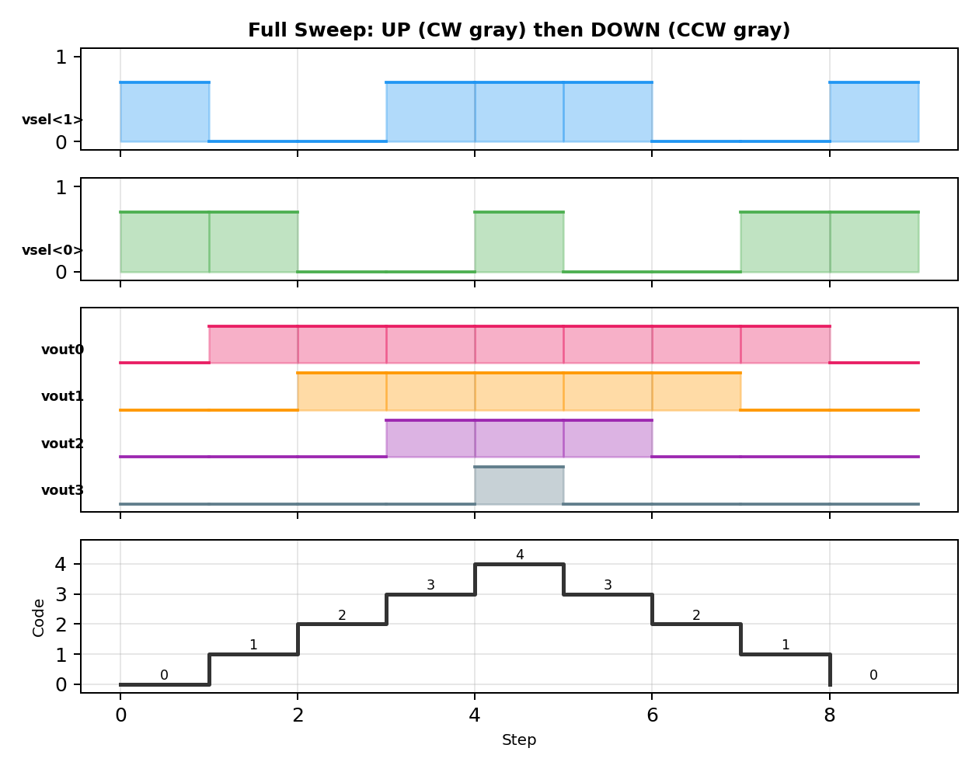
- Zigzag — UP 3, DOWN 2, UP 1 (direction reversal):
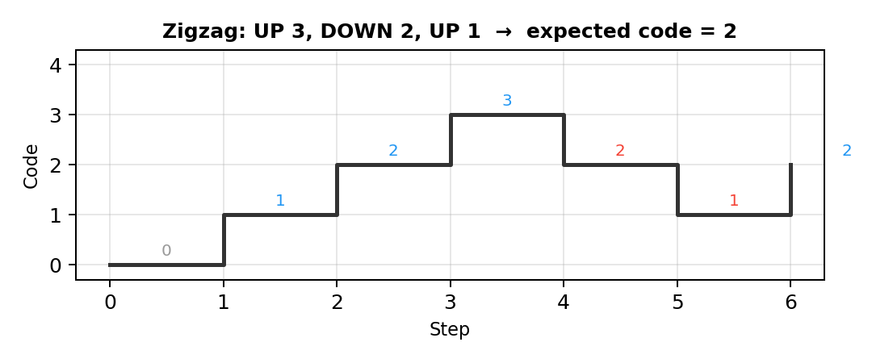

4. Valid and Invalid Inputs

4.1 Valid vsel Transitions (Gray Code Only)
Only single-bit transitions of vsel are valid. The gray code adjacency is:
00
╱ ╲
01 10
╲ ╱
11
Valid transitions (1 bit changes):
00 ↔ 01 (vsel<0> toggles)
00 ↔ 10 (vsel<1> toggles)
01 ↔ 11 (vsel<1> toggles)
10 ↔ 11 (vsel<0> toggles)

4.2 INVALID vsel Transitions
NEVER transition 2 bits simultaneously:
Transition | Bits changed | Risk | Severity
00 ↔ 11 | 2 (both) | Both mux selects change — intermediate state has undefined pair. Race condition. | CRITICAL — corrupts code
01 ↔ 10 | 2 (both) | Same — transient state is either 00 or 11, causing an unintended shift. | CRITICAL — corrupts code

4.3 Valid Boundary Inputs
Input | Valid value | Reason | If wrong
in_pre | 1 (VDD) | Feeds '1' from right (mux0 side) for UP shift | UP shifts inject 0 instead of 1 — inverted behavior
in_post | 0 (VSS) | Feeds '0' from left (mux3 side) for DOWN shift | DOWN shifts inject 1 instead of 0 — inverted behavior

Note: in_pre=1 and in_post=0 must be stable DC. If these float or glitch, the thermometer code will be corrupted.

4.4 Post-Saturation Behavior (DANGER)
WARNING: If the gray code counter continues stepping after saturation, the code jumps by ±2 when passing through vsel=00 (anchor state).
Scenario | Current state | Next CW step | Result | Problem
UP past max | code 4 @ vsel=01 | vsel=00 | Code 2 (forced) | −2 jump!
DOWN past min | code 0 @ vsel=10 | vsel=00 | Code 2 (forced) | +2 jump!

The grey controller MUST detect saturation (code 0 or 4) and stop the gray code counter. Otherwise the DAC output will oscillate.

5. Reset Procedure

5.1 Reset Inversion
IMPORTANT: The reset input is INVERTED by the hardware: all vout<3:0> = !vin_rst_b. Since vin_rst_b is a single bit shared across all 4 muxes, the unit can only reset to all-0 (code 0) or all-1 (code 4).
vin_rst_b | All vout | Unit code | Release vsel
1 | 0000 | 0 (fully OFF) | 10 or 11
0 | 1111 | 4 (fully ON) | 01 or 11

Since both code 0 and code 4 are valid at vsel=11, the only release vsel that works for a mixed array of ON/OFF units is vsel=11.

5.2 Why Toggling vsel During Reset is NOT Required
Because vin_rst_b is shared (all muxes see the same value), the reset always produces a uniform output (all 0s or all 1s). At vsel=11, all mux sel=1, so every mux reads its in1 cross-link — which is another vout with the same reset value. This means voutb naturally aligns:
During reset (sel_rst=1) at vsel=11:
All vout = !vin_rst_b (forced by reset mux)
All in1 = vout_crosslink = !vin_rst_b (all same value)
All voutb = !(in1) = vin_rst_b ← matches vin_rst_b!
On release (sel_rst 1→0):
vout = !voutb = !vin_rst_b = target ✓ clean, no glitch
Conclusion: With shared vin_rst_b and vsel=11, no toggling is needed.
However, if the design were modified to have per-mux in_rst with different values (e.g., in_rst = 0011 for code 2), toggling would be required — see Warning in Section 11.

5.3 Correct Reset Sequence
+------------------------------------------------------------+
| 1. Set vsel = 11 (MUST be 11 before and during reset!) |
| 2. Set vin_rst_b per unit (0 -> ON/1111, 1 -> OFF/0000) |
| 3. Assert sel_rst = 1 |
| 4. Wait >= t_settle for voutb to align |
| 5. Deassert sel_rst = 0 (no toggling needed) |
+------------------------------------------------------------+
vsel: ▔▔▔▔▔▔▔▔▔▔▔▔▔▔▔▔ 11 ▔▔▔▔▔▔▔▔▔▔▔▔▔▔▔▔▔▔▔▔▔
vin_rst_b: XXXX< 0 or 1, stable >XXXXXXXXXXXXXXXXXXXXXXXXX
sel_rst: _________╱▔▔▔▔▔▔▔▔▔▔▔▔╲________________________
vout: XXXXXXXXX< !vin_rst_b >───────────────────────────
⚠ CRITICAL: vsel MUST be 11 when sel_rst is released.
Releasing at any other vsel (especially 00) will FORCE the
wrong code immediately (vsel=00 always forces code 2).

- Simulated reset sequence (unit reset to code 0, in_rst=1111, vsel=11 held constant, no toggling):
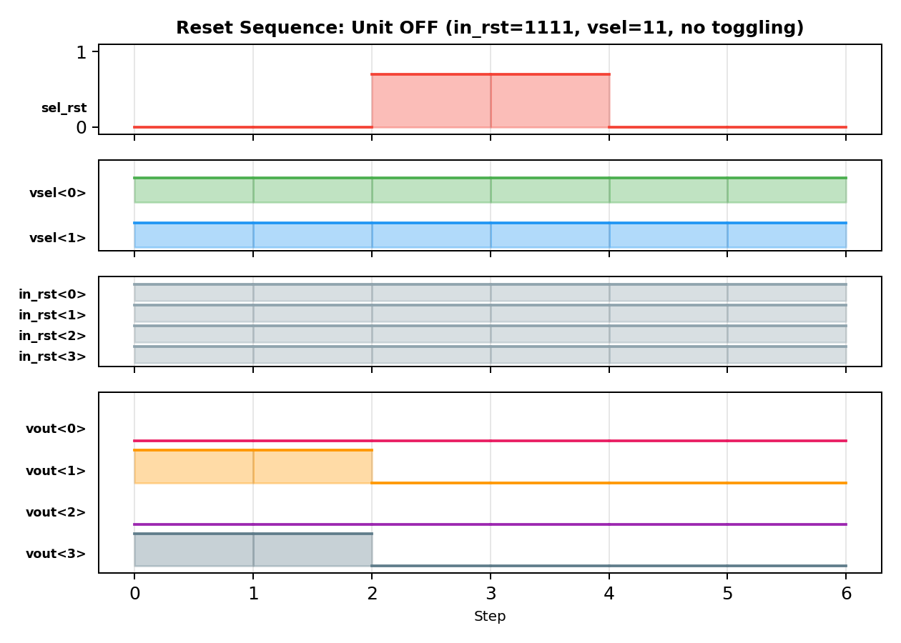

5.4 Invalid Reset Sequences
Sequence | Problem | Result
Release at vsel ≠ 11 | Pair forms at position incompatible with all-same-value code | Some units may latch wrong code
vin_rst_b changes during sel_rst=1 | Transient mismatch between vout and voutb | Possible glitch on release
sel_rst released before voutb settles | voutb hasn't reached steady state | Output glitches briefly before pair resolves

5.5 Release vsel Rule
With shared vin_rst_b, the only valid release vsel is 11. This is because vsel=11 creates a pair at (1↔2), and since all bits are uniform (all 0 or all 1), the pair always latches correctly.
No other vsel value is safe as a universal release across a mixed array of units with different vin_rst_b values.

5.6 Full Operational Sequence
This section describes the complete lifecycle of the SR block from power-on through normal shifting. This is the primary reference for system integration.
+--------------------------------------------------------------------+
| FULL OPERATION SEQUENCE |
+--------------------------------------------------------------------+
| |
| PHASE 0: STATIC SETUP (before reset) |
| - in_pre = 1 (VDD) -- right boundary (mux0), always high |
| - in_post = 0 (VSS) -- left boundary (mux3), always low |
| - These NEVER change during operation |
| |
| PHASE 1: RESET |
| - Set vsel = 11 |
| - Set vin_rst_b per unit (0 = ON/1111, 1 = OFF/0000) |
| - Assert sel_rst = 1 |
| - Wait >= t_settle |
| - Deassert sel_rst = 0 |
| - Block is now at target code, vsel = 11, ready to shift |
| |
| PHASE 2: FIRST SHIFT (from vsel=11) |
| - To go UP: toggle vsel<0> -> vsel = 01 (CW step) |
| - To go DOWN: toggle vsel<1> -> vsel = 10 (CCW step) |
| |
| PHASE 3: NORMAL OPERATION (gray code stepping) |
| - CW (UP): 11 -> 01 -> 00 -> 10 -> 11 -> ... (+1 per step) |
| - CCW (DOWN): 11 -> 10 -> 00 -> 01 -> 11 -> ... (-1 per step) |
| - Direction reversal: just reverse the gray code sequence |
| - STOP at saturation (code 0 or code 4 per unit) |
| |
+--------------------------------------------------------------------+

5.6.1 State After Reset
Immediately after releasing sel_rst, the system is in this state:
Signal | Value | Notes
vsel<1:0> | 11 | Pair at (1↔2), both code 0 and code 4 are stable
sel_rst | 0 | Normal operation mode
vin_rst_b | don't care | Ignored when sel_rst=0
in_pre | 1 | Constant — right boundary (mux0 side)
in_post | 0 | Constant — left boundary (mux3 side)
vout<3:0> | 0000 or 1111 | Per-unit, set by vin_rst_b during reset

5.6.2 First Gray Code Step
The first shift always starts from vsel=11. The direction determines which bit to toggle:
Direction | Toggle | New vsel | Effect on boundary unit
UP (CW) | vsel<0>: 1→0 | 10 | Pair moves to (0↔1), captures '1' from in_pre → +1
DOWN (CCW) | vsel<1>: 1→0 | 01 | Pair moves to (2↔3), captures '0' from in_post → −1

Subsequent steps continue the gray code sequence. The controller must track the current vsel to know which bit to toggle next.

5.6.3 Saturation Handling
When a unit reaches code 0 (all OFF) or code 4 (all ON), further steps in the same direction are absorbed — the code clips. The controller MUST detect saturation and stop the gray counter, because one additional step past saturation passes through vsel=00 (the anchor state) and causes a ±2 code jump.
Normal saturation (safe):
code 4 @ vsel=11 → CW → vsel=01: code stays 4 (clipped)
code 0 @ vsel=11 → CCW → vsel=10: code stays 0 (clipped)
DANGER — one more step past saturation:
code 4 @ vsel=01 → CW → vsel=00: code JUMPS to 2 (−2!)
code 0 @ vsel=10 → CCW → vsel=00: code JUMPS to 2 (+2!)
The gray controller must stop before vsel reaches 00 at extremes.

5.6.4 Direction Reversal
Reversing direction is immediate — just reverse the gray code rotation. No special setup is needed. The cross-coupled pair correctly captures the new boundary value on the very next step.
Example: UP 2, then DOWN 1 (starting from code 2 @ vsel=00)
Step 1: CW 00→10 → code 3
Step 2: CW 10→11 → code 4
Step 3: CCW 11→10 → code 3 (immediate reversal, no dead step)
The net result is +1, as expected (2 + 2 − 1 = 3).

6. Complete Truth Tables

6.1 State Transition Table (Normal Operation)
For each (current code, current vsel) → single gray step → (next code, next vsel):
From code | From vsel | CW step  (UP) | New code | CCW step  (DOWN) | New code
0 | 11 | → 01 | 1 (+1) | → 10 | 0 (sat)
0 | 10 | → 11 | 0 (sat) | → 00 | 2 (+2 DANGER)
1 | 01 | → 00 | 2 (+1) | → 11 | 0 (−1)
2 | 00 | → 10 | 3 (+1) | → 01 | 1 (−1)
3 | 10 | → 11 | 4 (+1) | → 00 | 2 (−1)
4 | 11 | → 01 | 4 (sat) | → 10 | 3 (−1)
4 | 01 | → 00 | 2 (−2 DANGER) | → 11 | 4 (sat)

Gray shaded rows show saturation and the dangerous ±2 jump if the controller continues past saturation.

6.2 Reset Truth Table
With shared vin_rst_b, only code 0 and code 4 are achievable per unit. Release vsel must be 11 for both:
Target | vin_rst_b | Release  vsel=00 | Release  vsel=01 | Release  vsel=10 | Release  vsel=11
code 0 (OFF) | 1 | FAIL→c2 | FAIL→c1 | PASS ✓ | PASS ✓
code 4 (ON) | 0 | FAIL→c2 | PASS ✓ | FAIL→c3 | PASS ✓

Both rows pass at vsel=11 → use vsel=11 as the universal release state. No vsel toggling is required (see Section 7.5).

7. Scaling to 9-Bit DAC (511 codes)
Each 4-mux SR unit handles 5 thermometer codes (0 through 4). For a 9-bit DAC with 511 unit current sources, approximately 128 SR units are chained together:
Unit 0 Unit 1 Unit 2 Unit 127
+------+ +------+ +------+ +------+
| |--vout3->| |--vout3->| | . . . | |
| SR | in_post | SR | in_post | SR | | SR |-> in_post=0
| |<-in_pre-| |<-in_pre-| | | |
+------+ +------+ +------+ +------+
in_pre=1
All units share the same vsel<1:0> and sel_rst.
Each unit has its own vin_rst_b (1-bit per unit).
Total codes: 128 x 4 + 1 = 513 >= 511 needed.
The chaining works because each unit's boundary outputs (vout0/vout3) connect to the adjacent unit's boundary inputs (in_pre/in_post). The thermometer boundary slides across unit boundaries seamlessly.

7.1 Inter-Unit Port Mapping
Adjacent SR units connect through their boundary ports. The 1→0 thermometer boundary propagates across unit boundaries identically to intra-unit propagation:
Source | Signal | Destination | Purpose
Unit[n].vout3 | therm_out | Unit[n+1].in_post | Passes '1' or '0' into next unit (left side)
Unit[n+1].vout0 | therm_out | Unit[n].in_pre | Passes '1' or '0' into previous unit (right side)
Global | vsel<1:0> | All Unit[*].vsel | Same gray code control to all units
Global | sel_rst | All Unit[*].sel_rst | Shared reset enable
Per-unit | vin_rst_b | Each Unit[n].vin_rst_b | 1-bit per unit: 0 (→ON/1111) or 1 (→OFF/0000)

7.2 Boundary Crossing Example
When the thermometer boundary sits at the edge of a unit, one gray code step moves it into the adjacent unit:
Before (code = 4 in Unit[n], code = 0 in Unit[n+1]):
Unit[n]: [1, 1, 1, 1] Unit[n+1]: [0, 0, 0, 0]
vout3=1 ─────▶ in_post=1 (Unit[n+1] sees '1' at its left boundary)
After CW step (vsel toggles):
Unit[n]: [1, 1, 1, 1] Unit[n+1]: [1, 0, 0, 0]
The '1' from Unit[n].vout3 propagates into Unit[n+1].vout3,
then chains through mux3→mux2→... exactly as within a single unit.
Effective: global thermometer code increased by 1 (unit[n] stayed full,
unit[n+1] gained one '1')

7.3 Reset in Multi-Unit Configuration
Each unit has a single vin_rst_b input shared across all 4 internal muxes. All units share the same sel_rst and vsel<1:0>. The reset code decoder sets each unit's vin_rst_b based on whether the unit falls below or above the thermometer boundary:
- Units below the boundary (fully ON): vin_rst_b = 0 → vout = 1111
- Units above the boundary (fully OFF): vin_rst_b = 1 → vout = 0000
Constraint: the global reset code must be a multiple of 4 (0, 4, 8, ..., 508, 512). Partial thermometer codes within a unit are not achievable with shared vin_rst_b.

7.4 Reset to Mid-Code 256 (Design Target)
The CDR DAC resets to mid-code 256 (out of 511). Since 256 is exactly divisible by 4, every SR unit resets to either all-1s or all-0s — no unit holds a partial thermometer code.
Units | Count | vin_rst_b | vout (= !vin_rst_b) | State
Unit 0 – 63 | 64 | 0 | 1111 | Fully ON
Unit 64 – 127 | 64 | 1 | 0000 | Fully OFF

Total thermometer code = 64 × 4 = 256 ones. This corresponds to exactly half-scale output.
Since all units are either code 0 (0000) or code 4 (1111), the release vsel must be valid for both states simultaneously:
Unit state | Valid release vsel | Reason
0000 (code 0) | 10 or 11 | Pair at (0↔1) or (1↔2), all bits = 0
1111 (code 4) | 01 or 11 | Pair at (2↔3) or (1↔2), all bits = 1
Intersection | 11 only | Only vsel=11 satisfies both

Release vsel MUST be 11 (vsel<1:0> = 11) for mid-code 256 reset.

7.5 No Toggling Required
Because vin_rst_b is shared across all 4 muxes, every unit always resets to a uniform state (all 0s or all 1s). The voutb nodes inside each mux naturally align with vin_rst_b at vsel=11 — no vsel toggling is needed.
At vsel=11, all mux sel=1, so every mux selects its in1 (cross-link) input. When all 4 vout bits are identical:
voutb = !(sel=1 ? in1 : in0) = !(vout_crosslink) = !vout = vin_rst_b
Unit at code 4 (vout=1111, vin_rst_b=0):
All in1 = 1 → all voutb = 0 = vin_rst_b ✓ (4/4 match)
Unit at code 0 (vout=0000, vin_rst_b=1):
All in1 = 0 → all voutb = 1 = vin_rst_b ✓ (4/4 match)
On release: vout = !voutb = !vin_rst_b = target ✓ clean, no glitch
Since vin_rst_b is a single shared signal, every unit is always fully uniform during reset. This guarantee eliminates the need for vsel toggling entirely — voutb always aligns with vin_rst_b at vsel=11.

7.6 Mid-Code 256 Reset Sequence
+------------------------------------------------------------+
| 1. Set vsel = 11 |
| 2. Set vin_rst_b per unit: |
| Units 0-63: vin_rst_b = 0 (-> vout = 1111) |
| Units 64-127: vin_rst_b = 1 (-> vout = 0000) |
| 3. Assert sel_rst = 1 |
| 4. Wait for voutb to settle (>= 1 x t_cell) |
| 5. Deassert sel_rst = 0 (no toggling needed) |
+------------------------------------------------------------+
vsel: ▔▔▔▔▔▔▔▔▔▔▔▔▔▔▔▔ 11 ▔▔▔▔▔▔▔▔▔▔▔▔▔▔▔▔▔▔▔▔
vin_rst_b: XXXX< per-unit 0 or 1 (stable) >XXXXXXX
sel_rst: _________╱▔▔▔▔▔▔▔▔▔▔▔╲____________________
vout: XXXXXXXXX< 256 ones | 256 zeros >──────────

8. Risks and Mitigations
# | Risk | Cause | Impact | Mitigation
1 | Post-saturation ±2 jump | Gray counter continues past code 0 or 4 | DAC output jumps 2 codes | Grey controller must detect saturation and stop
2 | 2-bit vsel transition | Both vsel bits change simultaneously | Undefined intermediate state, code corruption | Ensure gray-code sequencing in controller
3 | Reset value lost on release | sel_rst released at vsel ≠ 11 | Wrong initial DAC code → CDR starts at wrong freq | Always release at vsel=11
4 | Reset polarity | vin_rst_b sense confused (vout = !vin_rst_b) | DAC resets to inverted code | vin_rst_b=0 → ON (1111), vin_rst_b=1 → OFF (0000)
5 | Metastability in cross-coupled pair | Pair forms from muxes with different values | Output may take long to resolve or resolve wrong | Only occurs at design errors; normal gray steps always form pairs from agreeing muxes
6 | Boundary input glitch | in_pre or in_post not stable | Wrong value injected at thermometer boundary | Tie in_pre=VDD, in_post=VSS with decoupling
7 | Non-thermometer state | SEU, noise, or illegal reset | DAC output undefined, may not recover via shifting | Reset after anomaly detection

9. Timing Constraints

9.1 Mux Propagation Delay
Each mux_wr2 cell contains two cascaded inverting muxes (transmission gate + output inverter). The propagation delay through one cell is:
t_mux = t_TG + t_INV (per stage)
t_cell = 2 × t_mux (two cascaded stages: I_mux + I_mux_rst)
At TSMC 2nm, SLVT, 0.9V, TT corner:
t_TG ≈ 5–10 ps (transmission gate)
t_INV ≈ 5–8 ps (inverter)
t_cell ≈ 20–36 ps per mux_wr2 cell

9.2 Cross-Coupled Pair Settling
When a gray code step moves the cross-coupled pair position, the new pair must resolve through positive feedback. The settling time depends on the regeneration time constant of the cross-coupled inverters:
t_settle = t_cell × N_loops
Worst case: pair resolves from near-metastable state
t_regen ≈ τ × ln(V_DD / ΔV_initial)
Typical: pair captures a strong '1' or '0' from boundary
t_settle ≈ 2–3 × t_cell ≈ 40–108 ps
Note: In normal gray code operation, the pair always captures
a rail-to-rail boundary value, so metastability does NOT occur.
Settling is fast (2–3 loop delays).

9.3 Multi-Unit Propagation
In the chained 128-unit configuration, a single gray code step only changes the thermometer code by ±1. The change propagates through at most 1 unit boundary (2 mux cells: vout3 → in_post → mux3 → mux2...). There is no ripple carry across multiple units.
Worst-case single-step delay (boundary crossing):
t_step = t_cell (source unit) + t_wire + t_cell (dest unit)
≈ 2 × t_cell + t_wire
≈ 40–72 ps + routing delay

9.4 vsel Setup / Hold Constraints
The vsel signals are the select inputs of transmission-gate muxes. They must be stable when the mux output is being sampled by the cross-coupled pair.
Parameter | Constraint | Notes
t_setup(vsel) | > t_settle | vsel must be stable before pair resolves
t_hold(vsel) | > 0 | vsel must remain stable until pair is latched
t_vsel_skew | < t_cell / 2 | Max skew between vsel<1> and vsel<0> (to prevent transient 2-bit change)
Min vsel period | > t_settle + margin | Allow pair to resolve fully before next toggle

9.5 Reset Timing
Parameter | Constraint | Notes
t_rst_setup(vin_rst_b) | > t_cell before sel_rst↑ | vin_rst_b must be stable before asserting reset
t_rst_hold(vin_rst_b) | > 0 after sel_rst↓ | vin_rst_b must hold through release
t_rst_min_width | > t_settle | Reset must stay asserted long enough for voutb to settle
t_release_setup(vsel) | > t_cell before sel_rst↓ | vsel=11 must be stable before releasing reset

10. Spectre Netlist Reference
The following Spectre subcircuit definitions are the authoritative source for the block connectivity. All analysis in this document was verified against these netlists.

10.1 Bare Mux: hyp_adc_cdr_dac_mux2b_unit
Transmission-gate 2:1 mux with output inverter. Function: voutb = !(sel ? in1 : in0). 6 ports (selb generated internally).
subckt hyp_adc_cdr_dac_mux2b_unit in0 in1 sel vcca0p9 voutb vssx
// Transmission gate mux (TG pass gates + output inverter)
// sel=0: passes in0 through TG (PMOS gate=sel, NMOS gate=selb)
// sel=1: passes in1 through TG (PMOS gate=selb, NMOS gate=sel)
// Internal inverter drives voutb
// Net function: voutb = !(sel ? in1 : in0)
// Note: selb is generated internally (no external selb port)

10.2 Mux Wrapper: hyp_adc_cdr_dac_mux_wr2
Two cascaded inverting muxes: data mux → reset mux. The double inversion cancels in normal mode.
subckt hyp_adc_cdr_dac_mux_wr2 in0 in1 in_rst sel sel_rst vcca0p9 vout vssx
I_mux (in0 in1 sel vcca0p9 voutb vssx)
hyp_adc_cdr_dac_mux2b_unit
// voutb = !(sel ? in1 : in0)
I_mux_rst (voutb in_rst sel_rst vcca0p9 vout vssx)
hyp_adc_cdr_dac_mux2b_unit
// vout = !(sel_rst ? in_rst : voutb)
// Normal (sel_rst=0): vout = !(voutb) = !!(sel?in1:in0) = sel?in1:in0
// Reset (sel_rst=1): vout = !(in_rst) = !in_rst

10.3 SR Unit: hyp_adc_cdr_dac_sr_unit
4 mux_wr2 instances with cross-coupled feedback wiring. All 4 muxes share a single vin_rst_b input.
// From Spectre netlist (hyp_adc_cdr_dac_sr_unit schematic):
I_mux0 (in_pre vout1 vin_rst_b vsel<1> sel_rst vcca0p9 vout0 vssx)
hyp_adc_cdr_dac_mux_wr2
// in0=in_pre, in1=vout1, in_rst=vin_rst_b, sel=vsel<1> → vout0
I_mux1 (vout0 vout2 vin_rst_b vsel<0> sel_rst vcca0p9 vout1 vssx)
hyp_adc_cdr_dac_mux_wr2
// in0=vout0, in1=vout2, in_rst=vin_rst_b, sel=vsel<0> → vout1
I_mux2 (vout3 vout1 vin_rst_b vsel<1> sel_rst vcca0p9 vout2 vssx)
hyp_adc_cdr_dac_mux_wr2
// in0=vout3, in1=vout1, in_rst=vin_rst_b, sel=vsel<1> → vout2
// NOTE: in0=vout3 (not vout1) — asymmetric wiring!
I_mux3 (in_post vout2 vin_rst_b vsel<0> sel_rst vcca0p9 vout3 vssx)
hyp_adc_cdr_dac_mux_wr2
// in0=in_post, in1=vout2, in_rst=vin_rst_b, sel=vsel<0> → vout3
// KEY: All 4 muxes share the SAME vin_rst_b signal.
// This guarantees uniform reset (all 0 or all 1).

10.4 Pin Ordering Convention
The hyp_adc_cdr_dac_mux_wr2 subcircuit port order is:
(in0 in1 in_rst sel sel_rst vcca0p9 vout vssx)
─┬─ ─┬─ ──┬── ─┬─ ──┬──── ───┬──── ─┬── ─┬──
│ │ │ │ │ │ │ │
│ │ │ │ │ │ │ └ Ground
│ │ │ │ │ │ └ Output
│ │ │ │ │ └ Supply (0.9V)
│ │ │ │ └ Reset mux select
│ │ │ └ Data mux select
│ │ └ Reset data input (shared as vin_rst_b at SR level)
│ └ Data input 1 (selected when sel=1)
└ Data input 0 (selected when sel=0)

11. Warning: Split in_rst (Non-Uniform Reset)
⚠ WARNING — APPLICABILITY LIMITATION
This document assumes the production design where all 4 muxes in each SR unit share a single vin_rst_b signal. If a future design modification splits in_rst into separate per-mux signals (in_rst<3:0>) with different values, the following sections of this document are NO LONGER VALID without additional analysis:
- Section 5.2 (no toggling required) — would need toggling
- Section 5.3 (simple reset sequence) — would need full gray cycle toggle
- Section 5.5 (vsel=11 as universal release) — may not be valid for all codes
- Section 7.5 (no toggling proof) — proof relies on uniform vout
- Section 7.3 (reset code must be multiple of 4) — partial codes become possible

11.1 Example: Split in_rst = 0011 (target code 2)
If in_rst were split per-mux to achieve code 2 (vout = 1100), the reset input would be in_rst<3:0> = 0011 (inverted). Here's why the simple vsel=11 reset FAILS:
Target: vout = [1, 1, 0, 0] = code 2
Split in_rst: mux0.in_rst=0, mux1.in_rst=0, mux2.in_rst=1, mux3.in_rst=1
During reset at vsel=11 (all sel=1, selecting in1 cross-links):
vout = [1, 1, 0, 0] (forced by per-mux in_rst: !0,!0,!1,!1)
But voutb depends on in1 = vout_crosslink:
mux0: in1 = vout1 = 1 → voutb0 = !(1) = 0 need in_rst[0]=0 ✓
mux1: in1 = vout2 = 0 → voutb1 = !(0) = 1 need in_rst[1]=0 ✗ MISMATCH
mux2: in1 = vout1 = 1 → voutb2 = !(1) = 0 need in_rst[2]=1 ✗ MISMATCH
mux3: in1 = vout2 = 0 → voutb3 = !(0) = 1 need in_rst[3]=1 ✓
Result: 2 out of 4 voutb nodes DON'T match in_rst!
On release: vout = !voutb = [1, 0, 1, 0] ≠ [1, 1, 0, 0] ← WRONG!
FIX: Must toggle vsel through a full gray cycle during reset
to force all voutb nodes to settle correctly, then release at
the correct hold vsel for code 2 (which is vsel=00, NOT 11).
This example demonstrates why the shared vin_rst_b architecture was chosen: it eliminates the voutb-alignment problem entirely by guaranteeing uniform outputs during reset.

